TCN4211
Telecommunication Networks

Lab Number 5
Title Configuring a Wireless Network

Author Name: Anaisy Garcia PID: 5734454

Oct 11



Florida International University

OBJECTIVES:
The objectives of this lab are building a wireless topology containing a wireless router, understanding how wireless networking works, learning how to configure a wireless router, and constructing and enabling WEP for a wireless LAN.

EQUIPMENT and COMPONENTS USED
For this lab the equipment used was:
- Laptop
- Cisco Packet Tracer Program
Within the Cisco Program, the components used were three generic PCs, and a wireless router.

EXPERIMENTAL METHOD AND PROCEDURE
- Build a topology using three generic pcs and a wireless router.
- Name the PCs “PC0”, “PC1”, ad “PC2”.
- Double click on PC0 and use the web browser.
- In the web browsers address bar type the IP address for the router being “192.168.0.1”.
- Type “admin” for username and “admin” for password.
- Scroll down to network setup, select DHCP server disabled, and then save settings at the bottom.
- Select continue.
- At the top select administration, change the password to test, and then save settings at the bottom.
- When asked for authorization again type “admin” for the username and “test” for the password.
- At the top select wireless, change the SSID to MotherNetwork, set the security mode to WEP, set the key to “0123456789”, and then save setting at the bottom.
- Open each laptop, select the config tab, click wireless0, change the SSID to “MotherNetwork”, set the authentication to WEP and set the WEP key to “0123456789”.
- On each laptop select desktop and set the IP addresses, subnet mask, and default gateway using the table below.
PC | IP | Subnet Mask | Default Gateway
PC0 | 192.168.0.2 | 255.255.255.0 | 192.168.0.1
PC1 | 192.168.0.3 | 255.255.255.0 | 192.168.0.1
PC2 | 192.168.0.4 | 255.255.255.0 | 192.168.0.1
- On each laptop, select PC wireless, select connect, click refresh, select the network “MotherNetwork”, and press connect.
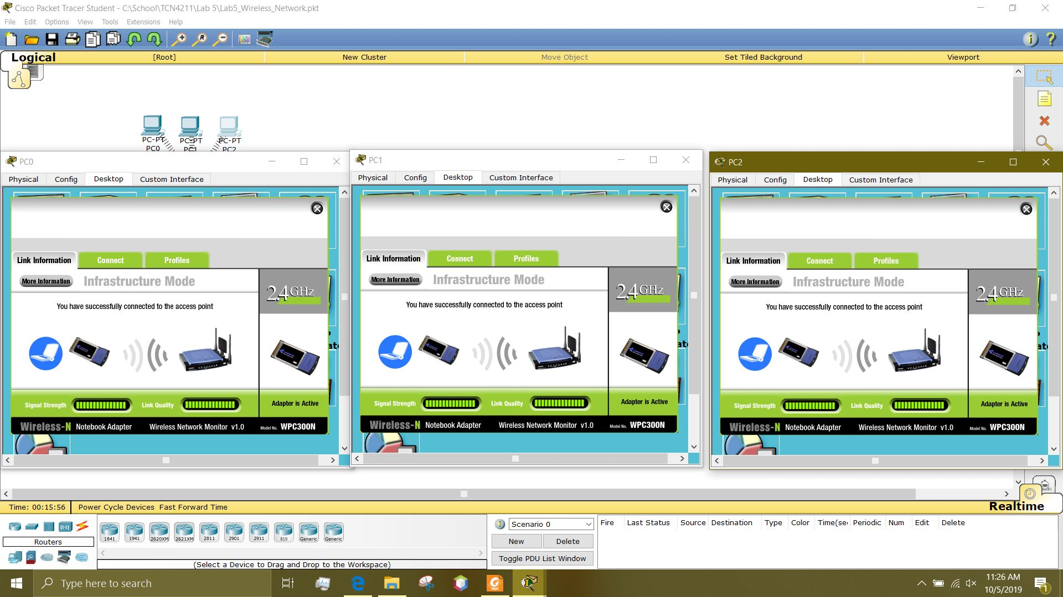
- Ping PC2 from PC0 to check stable connection.
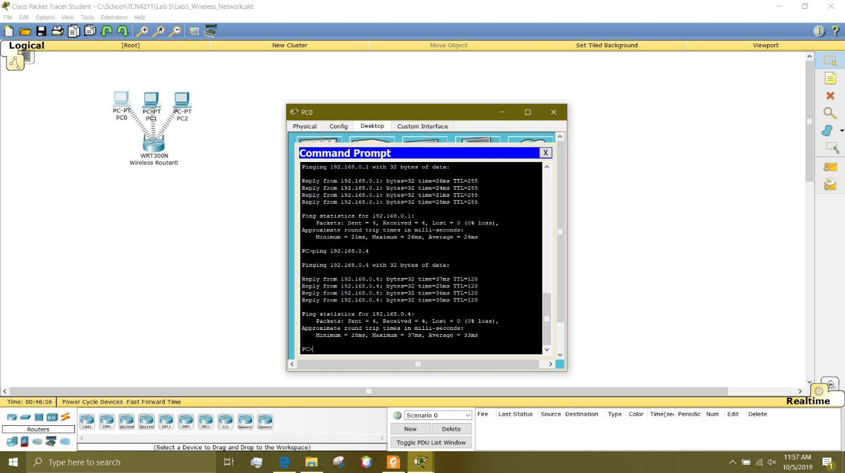

PROBLEMS/QUESTIONS
- What is the size (how many bits) of encryption key used in this lab?
40/64-Bits(10 Hex digits)
- What is the hexadecimal equivalent of encryption key used in this lab?
75BCD15
- What channel is used in this lab?
1
- Is it possible to change the communication channel to 2?
Yes
- If yes, how? List the necessary steps to change the communication channel to 2.
- Double click the wireless router.
- Select the config tab.
- Select wireless from the drop down.
- Click channel and change it to 2.

RECOMMENDATIONS and CONCLUSIONS
This lab consisted of understanding how to set up a wireless network and how to connect laptops to said network. WEP or Wired Equivalent Privacy is a security protocol that allows a WLAN to have a level of security and privacy. In this lab, an internal NIC within the laptops was used to access the wireless network. In the lab, it is learned that one can set up a wireless network using the interface on a router or a web browser.

